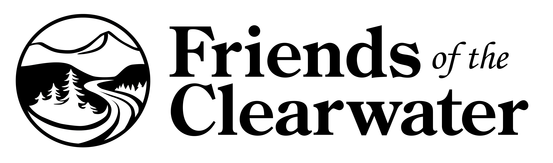
P.O. Box 9241
Moscow, ID 83843
(208) 882-9755
friendsoftheclearwater.org

