Friends of the Clearwater Board onboarding/training committee (Rick, Beth, Annette)
Goal: Ensure that incoming board members deeply understand FOC’s mission, vision and values; have access to institutional knowledge; get up to speed quickly; and encounter a board culture that is inclusive and supports organizational success. We have identified the following needs/first steps; please feel free to contact any of us to ask questions or share input.
- Have background information about FOC readily available
Idea: Create orientation packet, including an interactive presentation to be used for a new board member to meet with an experienced member and discuss, in a structured and consistent way, FOC’s unique identity: history, strengths and challenges, relationships to other environmental advocacy groups, and organizational culture.
- Strengthen everyone’s understanding of non-profit board roles in general.
Idea: Encourage all members to participate in continuing education like Powerhouse Boards: Training that transforms your board (Jan. 14 and 16, $30 with “HOLIDAY” code, info at https://nonprofitlearning.center/).
- Make board culture explicit rather than implicit.
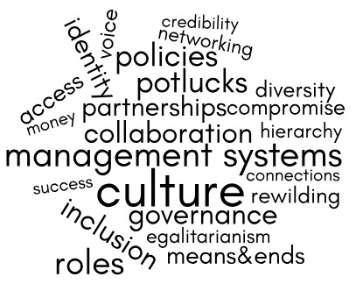
Idea: Hold a board-only, peer-led workshop to explore our intellectual and emotional reactions to important terms and concepts, as well as our assumptions about and expectations of each other and external partners.

- Clarify individual responsibilities and commitments of board members
Idea: Create a board matrix that includes demographic information, skills and interests, and specific individual goals for each board member.

